# Homework 6: User Management

# Task 4. Assigning User Mappings to Fixed Database Roles

## A. Assigning a user to a database role

## B. Verifying the results

5) Does it fail? Show the result in a screenshot. Describe your observation and explain why it fails.

Yes it fails. Looks like it failed to write into the tables, I imagine that we didn’t specify the database that we wanted to write the values into using the query. We also have User A listed under the denydatawriter properties so Test User A might not have write permissions.

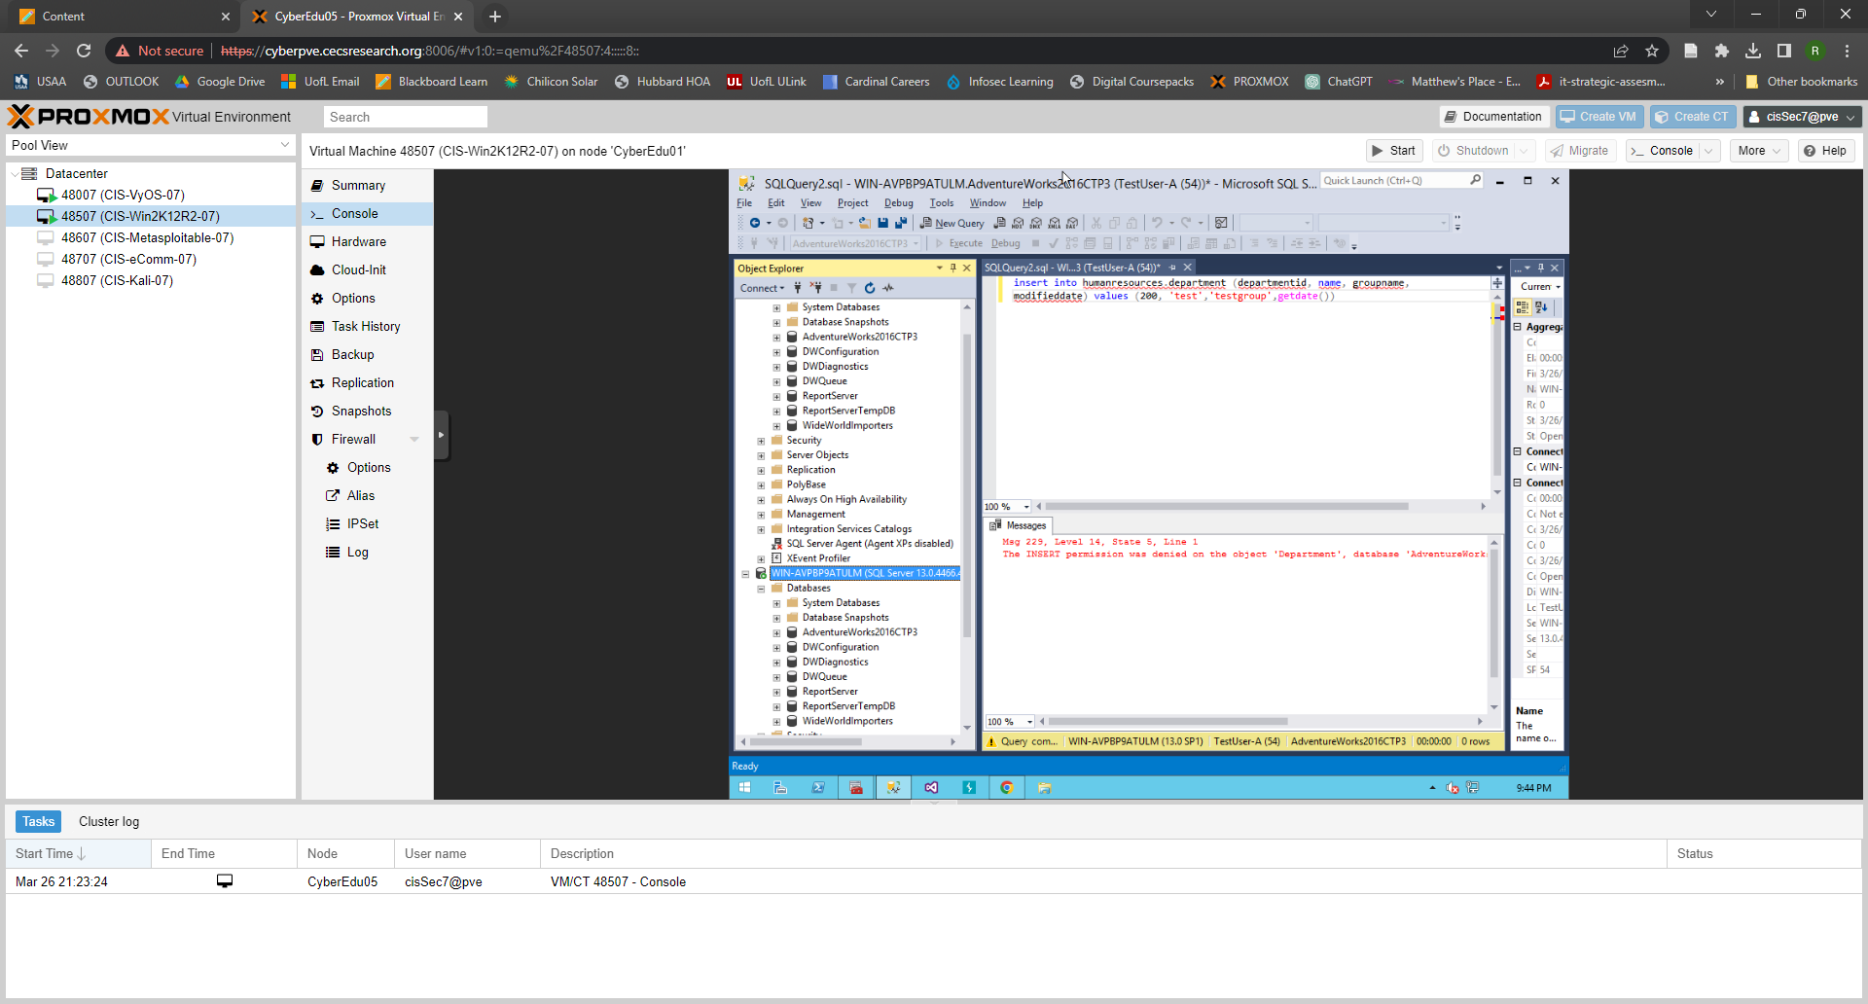

10) Does it fail? Show the result in a screenshot. Describe your observation and explain why it fails.

Yes it fails, it looks like we didn’t specify the database in which to find the tables to select the categories from.

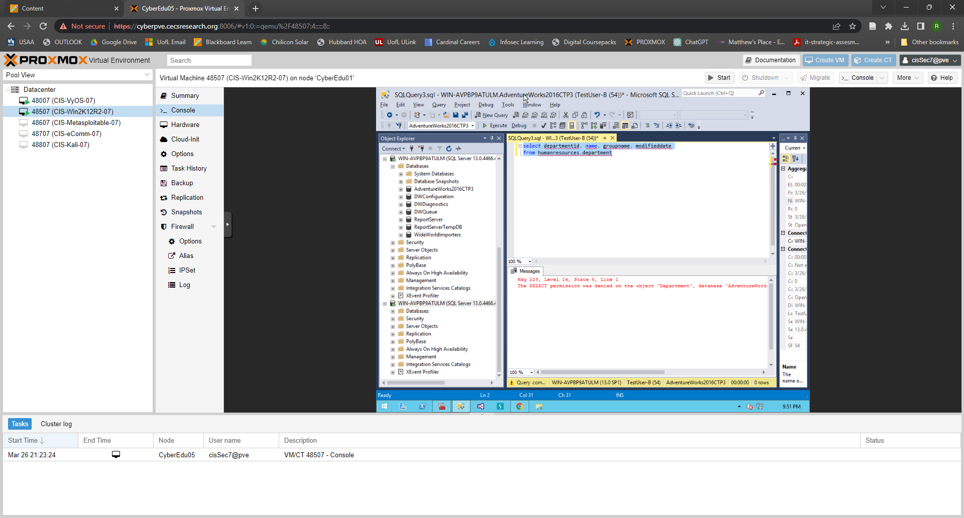

# Task 5. Creating a Custom Database Role

## A. Creating a custom database role

## B. Verifying results

4) Does it work? Show the result in a screenshot. Describe your observation and explain why it works.

Yes it works. Select permissions were given to Test User C and we also specified the database that we wanted to use this time.

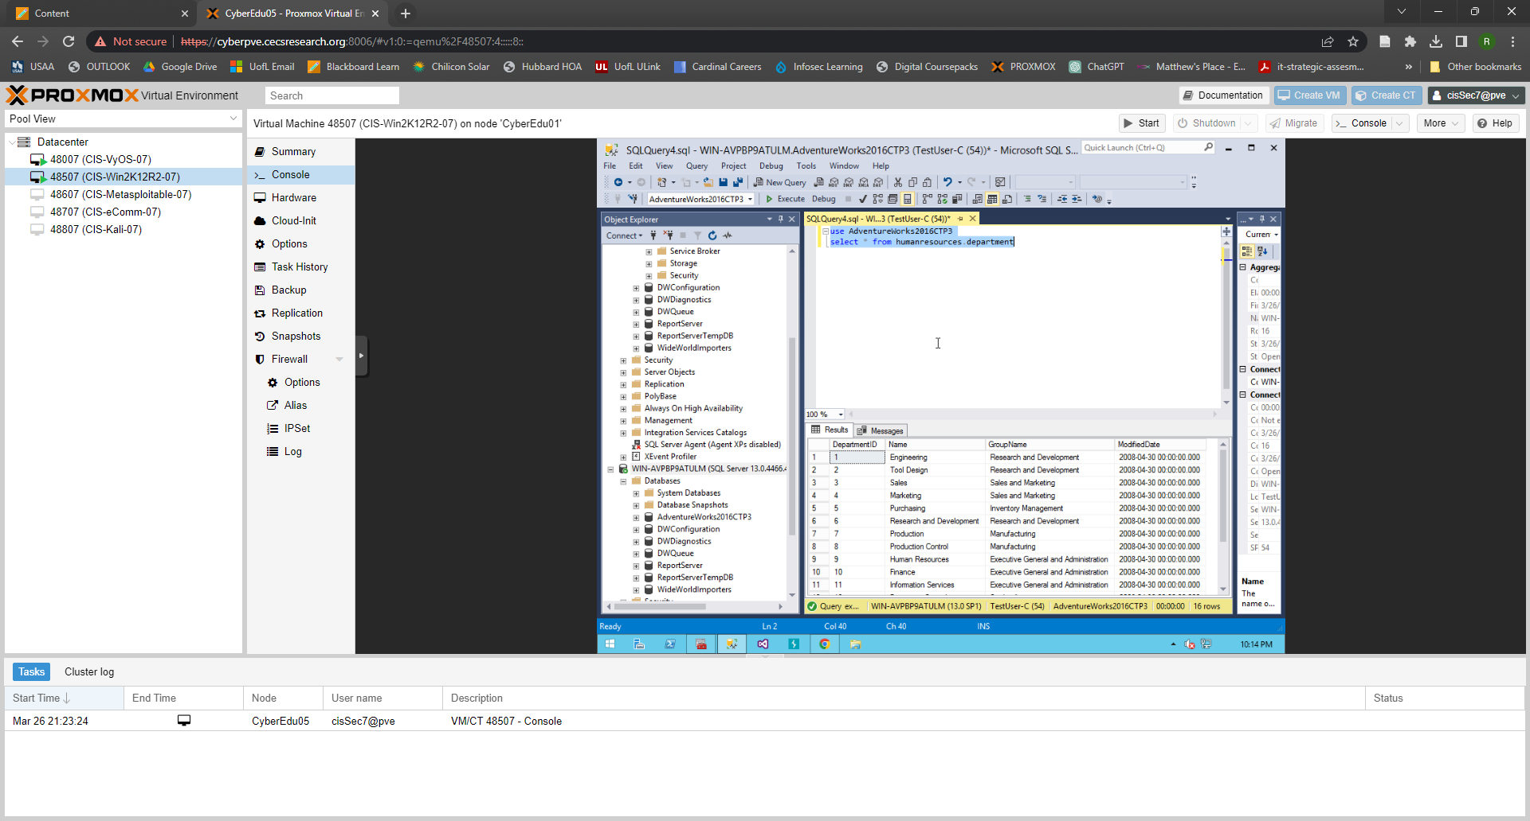

5) Does it fail? Show the result in a screenshot. Describe your observation and explain why it fails.

Yes it fails, we didn’t specifiy the database name to select from and Test User C does not have the proper permission.s

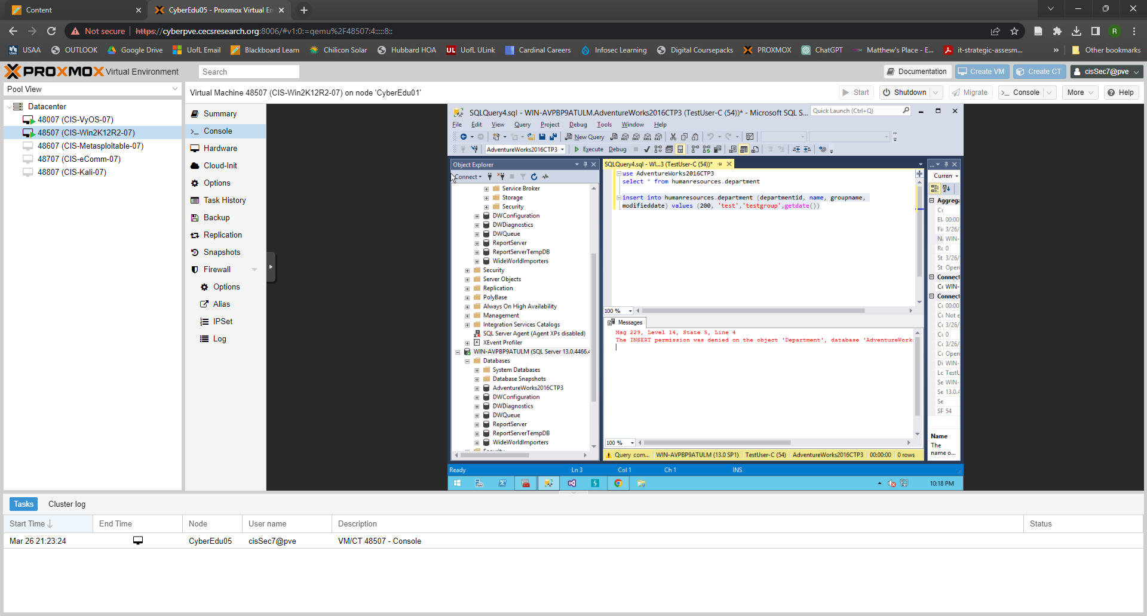

# Task 6. Creating an Application Role

## A. Creating an Application Role

## B. Verifying Results

2) Does it fail? Show the result in a screenshot. Describe your observation and explain why it fails.

Yes it fails, we secured the tables via the prior security measures we took. Also, the database isn’t named correctly as the adventureworks database is actually named Adventureworks2016CTP3

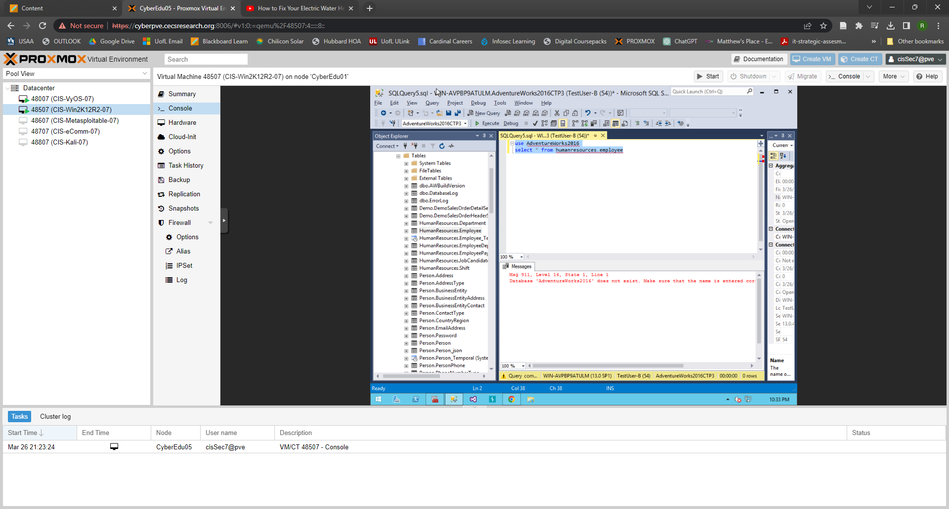

4) Does it work? Show the result in a screenshot. You have to click on Results to view the results. Describe your observation and explain why it works.

Yes it worked, we activated the application where we set the application settings to require a password.

# Task 7. Assigning Permissions

9) Does it work? Show the result in a screenshot. Describe your observation and explain why it works.

Yes it works, the “Select” property and function was checked in the securables so User A has access to use Select.

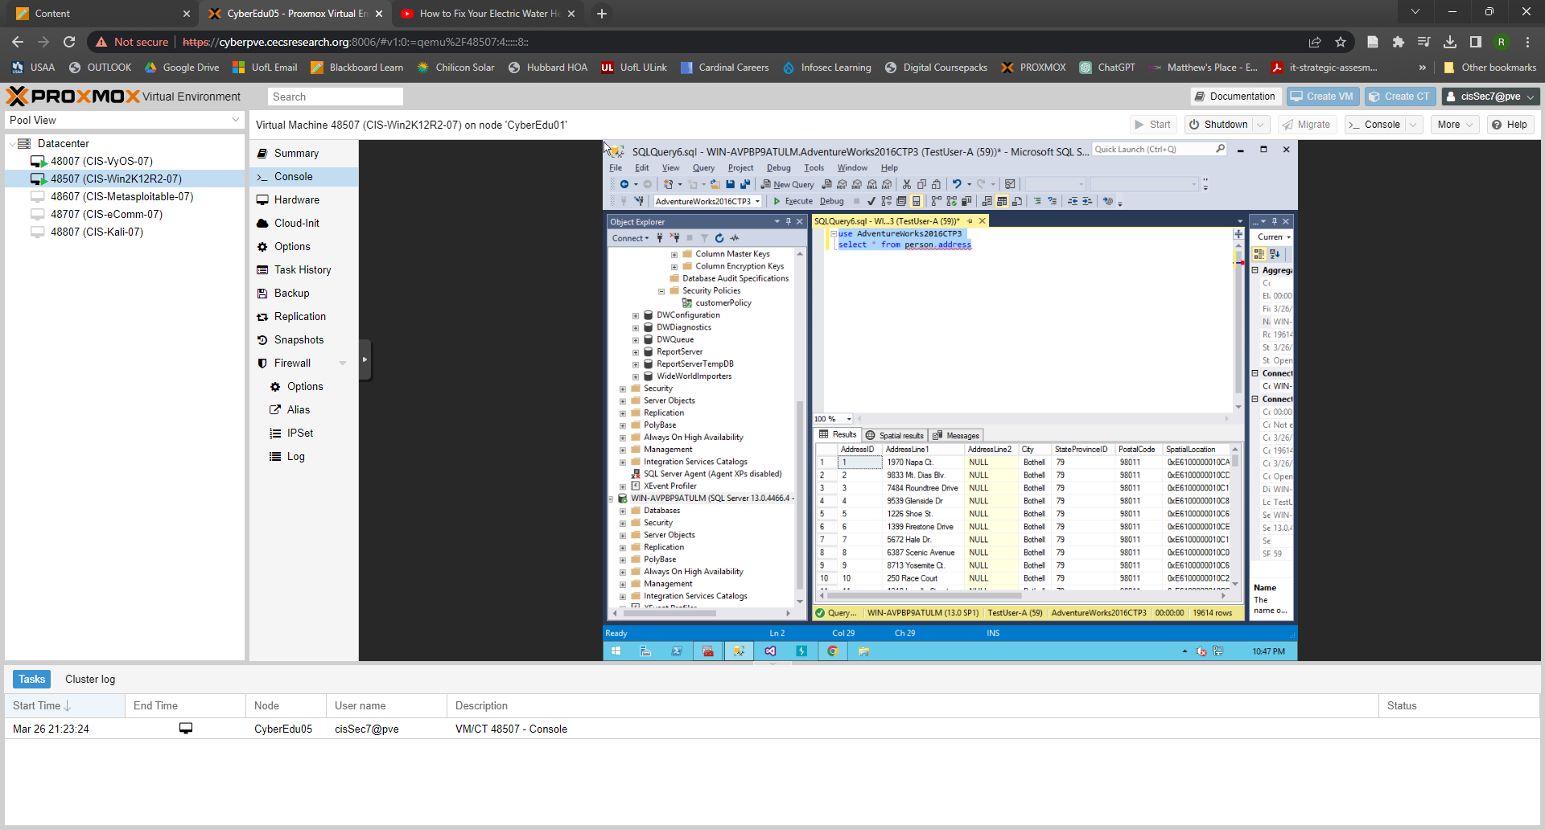

13) Run the previous query. Show the result in a screenshot. Describe your observation and explain why it fails.

Yes it fails, the Select button was unchecked so the access to use the SELECT function was removed for USER A.

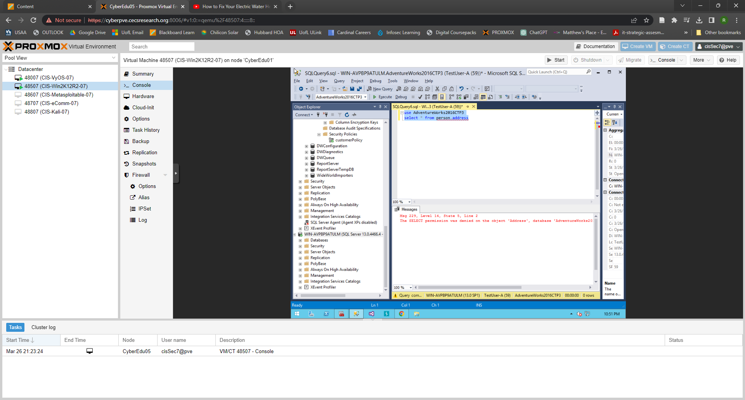

15) Run the previous query. Show the result in a screenshot. Describe your observation and explain why it works.

TEST USER A was able to be labeled a Datareader so they had access to read the data. They would likely not have access to manipulate, add, or remove data though.

19) Run the previous query. Show the result in a screenshot. Describe your observation and explain why it fails.

It fails because we checked the DENY on SELECT on the securables for USER A.

